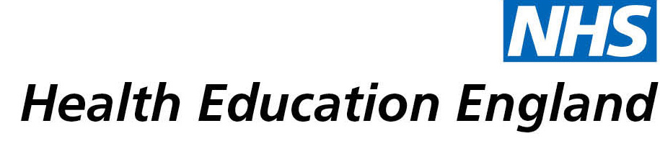

# Library and Knowledge Services case study

# Royal United Hospitals Bath NHS Foundation Trust*:* ACL Prehabilitation Service

Date *[06/07/2021]*

*Interview Date:* 21/05/2021

## Reason for enquiry

During the COVID19 2020 lockdown, the [Musculoskeletal](https://www.england.nhs.uk/elective-care-transformation/best-practice-solutions/musculoskeletal/)

(MSK) outpatient team had non-clinical time available to consider service development and improvements.

Lauren was assigned an Anterior Cruciate Ligament (ACL) prehabilitation (prehab) project. This service did not exist, but the team was aware that evidence suggested it could be beneficial to patient outcomes.

The aim was to set up a pilot study to prove the effectiveness of prehab for elective lower limb surgery (starting with knee ACL repair). The department was not currently funded for this service and wanted to demonstrate improved patient outcomes with better recovery along with cost-savings.

## What the knowledge and library specialist did

Lauren approached the Library in June 2020 to carry out a search to provide the evidence to back up the thinking behind the project focusing on improved outcomes and cost-savings.

A literature search was conducted across the healthcare databases – CINAHL, Medline and EMCARE.

Of specific value was information on outcome measures, questionnaires, international knee scores, strength building exercises.

# Impact of input from the library and knowledge service

* Pilot service running since Oct 2020
* Inpatient stay reduced post-op
* Closer relationship between physios and the specialists resulting in direct consultant referrals for patients to the prehab service
* More informed evidence-based service
* Prevention of surgery in some cases due to success of prehab and / or better-informed patient decision-making
* Some patients have been moved up the waiting–list because they are more surgically-ready following prehab
* Trauma and orthopaedic inpatient teams updated and informed
* Tailored patient care and creation of an information booklet – prehab and post-op.
* Patients better prepared for surgery and recovery, and more fully aware of what to expect
* Time-saving patient group established for prehab assessment
* Creation of a poster summarising the effectiveness of the project to-date – used to inform wider department

## Immediate Impact

* Clinician time saved by Library carrying out the searches
* Evidence provided to support the project and inform staff
* Decisions made on exercises and outcome measures to include
* Setting up of the pilot service
* Creation of a patient information booklet
* Experience of managing a project in a specific area for Lauren including a specific study of ten patients involved in the pilot to evaluate the effectiveness of the prehab programme

## Probable future Impact

* Business proposal to be presented, demonstrating cost-saving and patient benefit hoping for a fully funded service
* A formal care pathway in place
* Continued positive patient outcomes
* Continued multidisciplinary working and closer team working

## Name and Job Title:

Name: **Lauren Barriball**

Job Title: Rotational Physiotherapist (MSK team)

## For further information on how you can get similar support contact your local NHS library and knowledge service.

**Submission Details**

**[To be completed by Knowledge and Library Service at the point of submission]**

Name of Organisation Royal United Hospitals Bath NHS Foundation Trust

Knowledge and Library Service Contact Email *[lisa.hirst2@nhs.net]*

NHS Region South West

Title of Case Study **ACL Prehabilitation Service**

Sector Acute

Group Impacted Multiprofessional

Impact Types [Please select any which apply]

Contributed to personal or professional development.

Contributed to service development or delivery.

Facilitated collaborative working.

Health Information for Patients, Carers and the Public.

Improved the quality of patient care.

Mobilising evidence and organisational knowledge.

More informed decision making.

Productivity and efficiency.

Reduced risk or improved safety.

Saved money or contributed to financial effectiveness.

Improved health and wellbeing of staff and learners

I have consent from individuals referred to in this case study to share details nationally for advocacy and promotion.

Yes